N1
interface FastEthernet0/1
switchport trunk allowed vlan 10,180,190,250,310
interface FastEthernet0/2
switchport trunk allowed vlan 10,180,190,250,310
N2
interface FastEthernet0/2
switchport trunk allowed vlan 10,180,190,250,310
N3
interface FastEthernet0/1
switchport access vlan 310
switchport mode access
interface FastEthernet0/2
switchport trunk allowed vlan 10,180,190,250,310
interface FastEthernet0/3
switchport trunk allowed vlan 10,180,190,250,310
N4
interface FastEthernet0/2
switchport trunk allowed vlan 10,180,190,250,310
N5
interface Port-channel1
switchport trunk allowed vlan 10,180,190,250,300,310
interface FastEthernet0/2
switchport trunk allowed vlan 10,180,190,250,310
interface FastEthernet0/3
switchport access vlan 300
switchport mode access
N6
interface Port-channel1
switchport trunk allowed vlan 10,180,190,250,300,310
interface Port-channel2
switchport trunk allowed vlan 10,180,190,250,310
N7
deleted
N8
interface Port-channel1
switchport trunk allowed vlan 10,180,190,250,310
interface FastEthernet0/1
switchport trunk allowed vlan 10,180,190,250,310
interface FastEthernet0/2
switchport access vlan 310
switchport mode access
R1
interface GigabitEthernet0/1.300
encapsulation dot1Q 300
ip address 131.218.60.161 255.255.255.224
ip route 148.55.104.0 255.255.255.0 131.218.60.162
R2
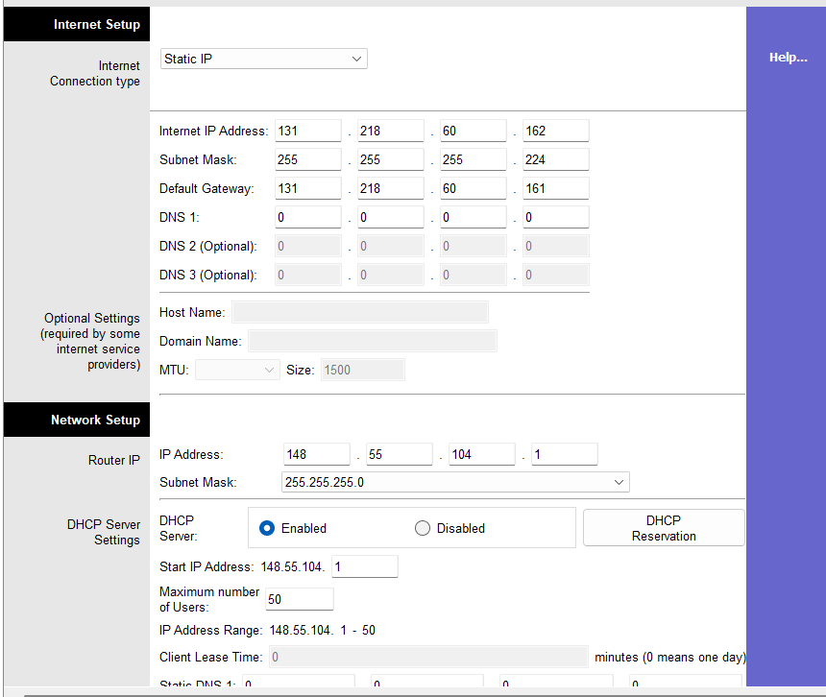
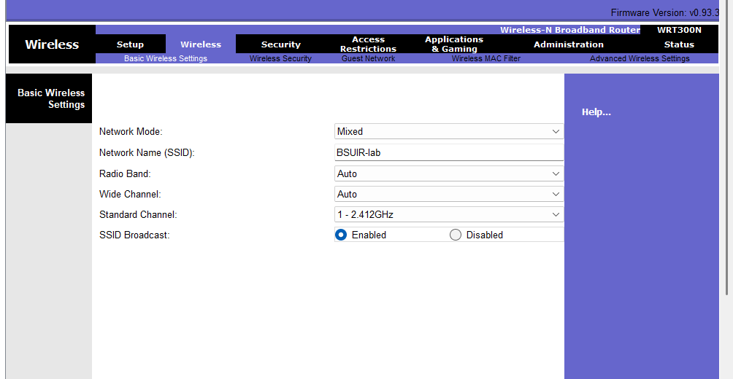
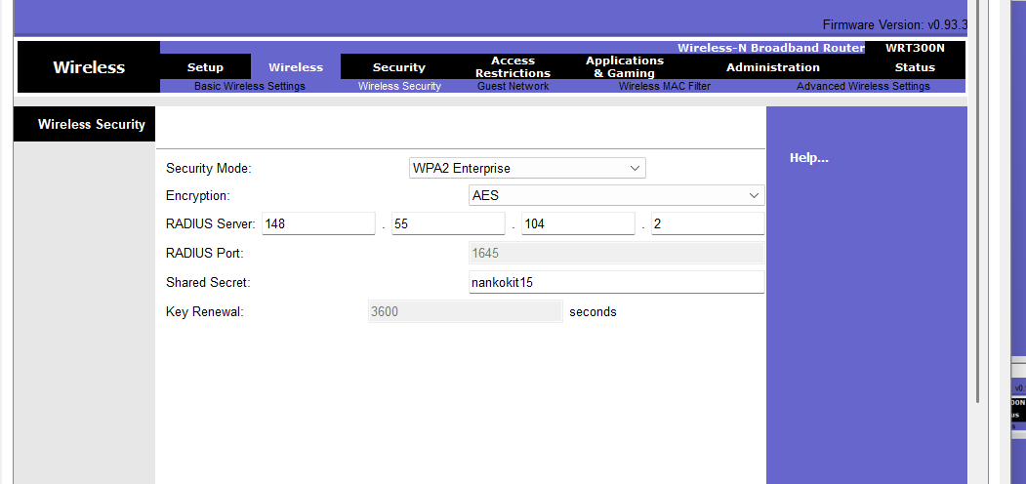
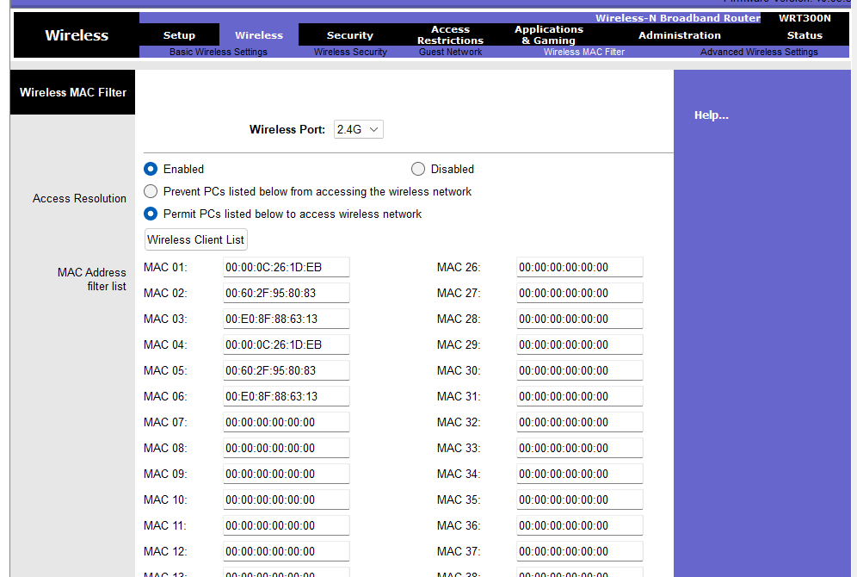
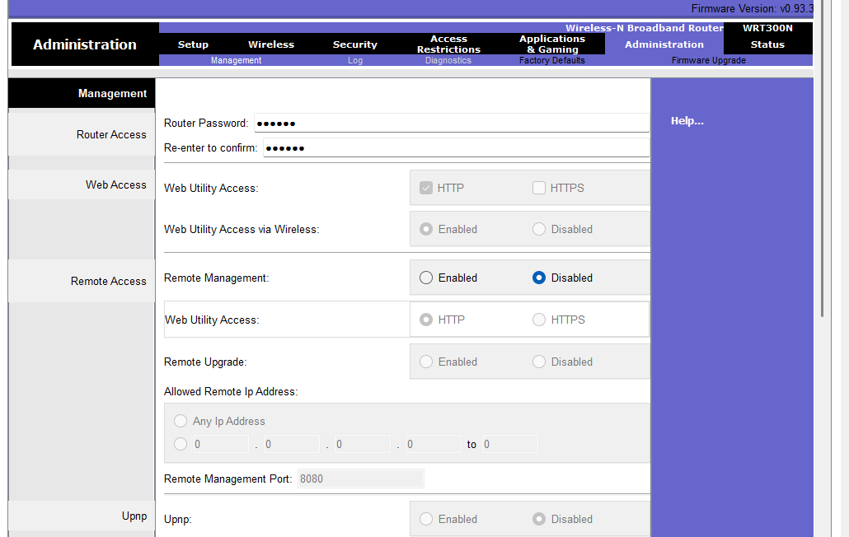
SERVER0
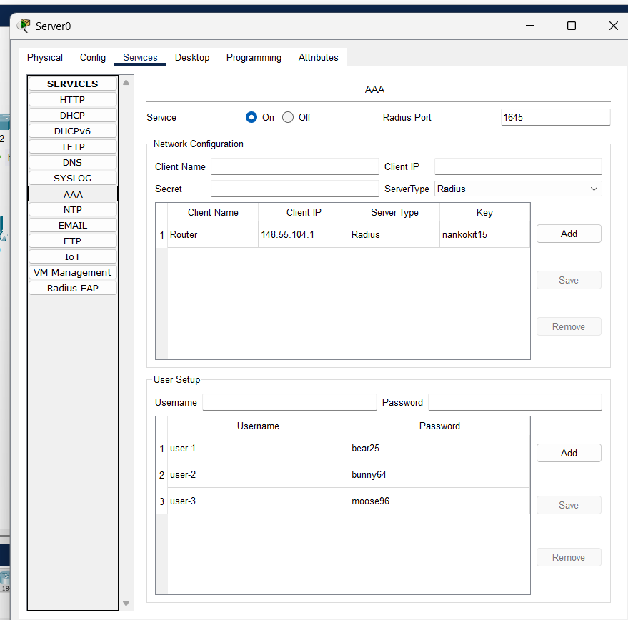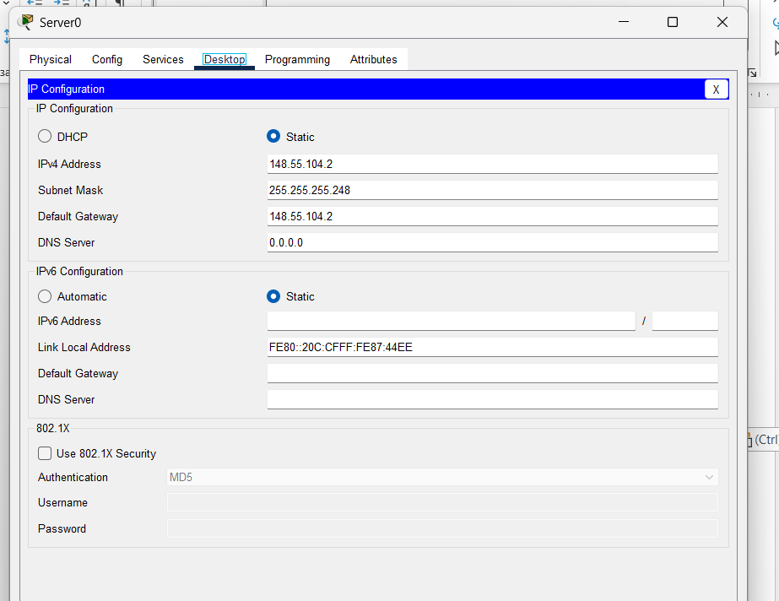
LAPTOP4
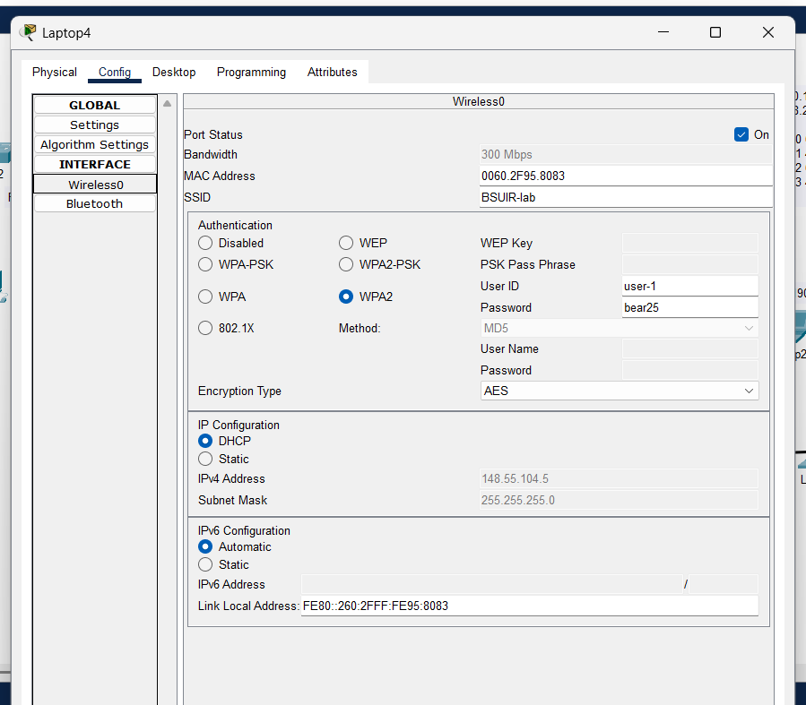
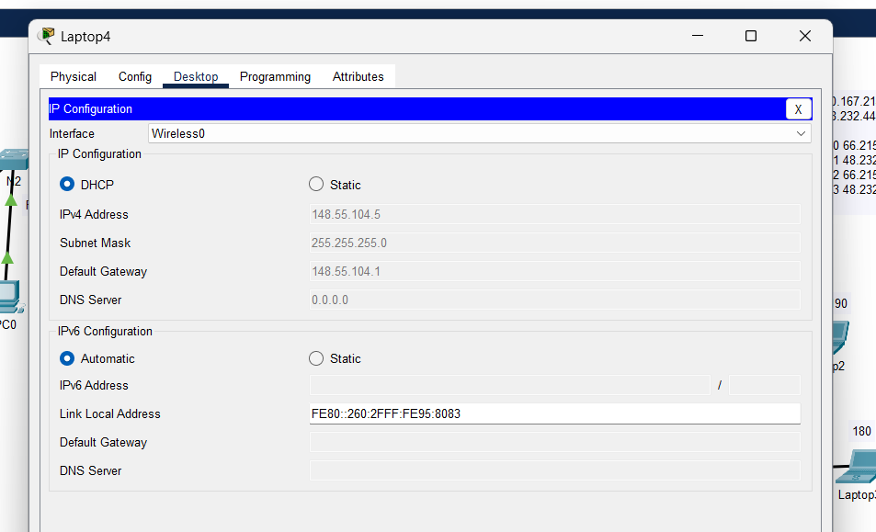
PC2
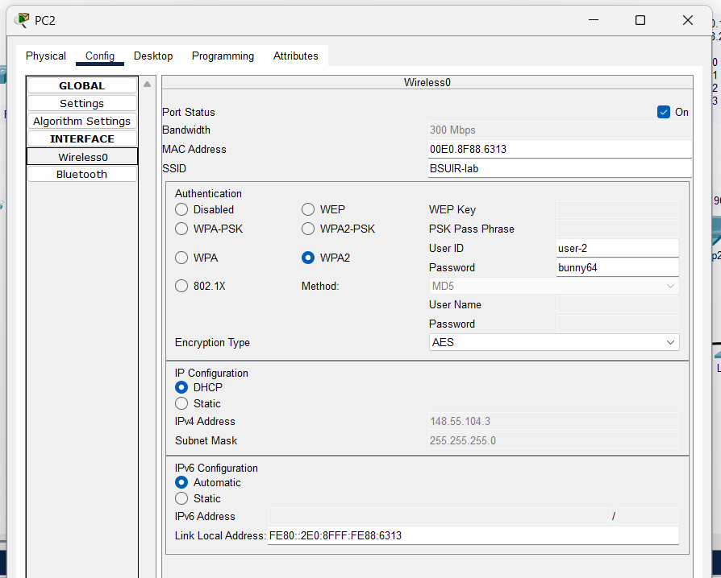
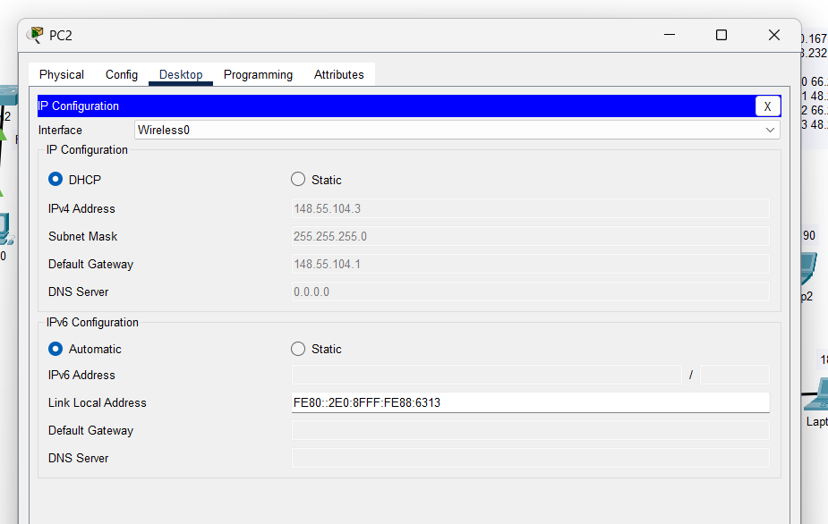

SMATRPHONE
